**Name – Zoysa ERL**

**IT Number – IT2410502**

**i)**

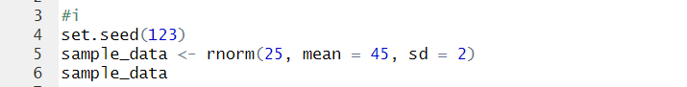

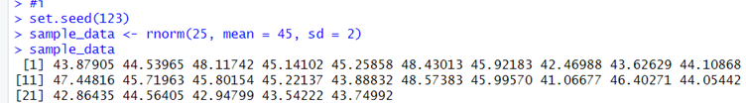

**ii)**

